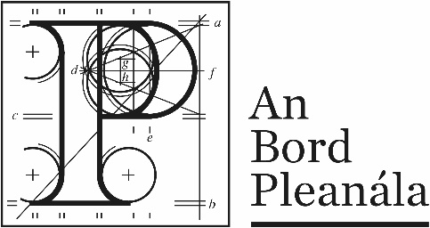 | Memorandum
 | ABP-313216-22

To: | Planning Inspector
From: | Ashling Doherty, Executive Officer
Re: | 280 no. apartments, creche and associated site works Bessborough, Ballinure, Blackrock, Co. Cork
Date: | 15th June 2022
- Please find hereunder an application for permission for the above-mentioned proposed development. A fee of €60,057.00 has been submitted with the application. Two printed copies and three electronic copies of the application documentation have been received in accordance with article 297(5) of the Planning and Development (Strategic Housing Development) Regulations 2017.

- A website has been created: www.themeadowsshd.ie

- The planning application was valid.

- Pre-application consultations in accordance with section 5 of the Act of 2016 were held with under reference ABP-311438-21 ABP’s Opinion was that the documents submitted requires further consideration and amendment to constitute a reasonable basis for an application for strategic housing development.

- The planning application contains documents submitted in accordance with the Planning and Development (Housing) and Residential Tenancies Act 2016.

- A EIAR has been submitted with this application.

- An NIS was submitted with this application.

- The Material Contravention Statement can be permitted under the provisions of the Planning and Development (Housing) and Residential Tenancies Act 2016.

- A submission was received from Irish Water on 5th May 2022 which states that the Applicant has engaged with Irish Water in respect of design proposal for which they have been issued a Statement of Design Acceptance for the development.
- The public notice was published in The Echo newspaper dated 30th March 2022. The site notice was erected on 30th March 2022.

- The prescribed bodies for the purposes of the application are set out in article 295 of the Planning and Development (Strategic Housing Development) Regulations 2017. The following bodies were circulated with the application documentation in accordance with the advice from ABP: 311438-21

- Minister for Culture, Heritage and the Gaeltacht (Development Applications Unit)
- The Heritage Council
- An Taisce
- An Chomhairle Ealaíon
- Fáilte Ireland
- Irish Water
- Transport Infrastructure Ireland
- National Transport Authority
- Cork City Childcare Committee
- Minister for Children, Equality, Disability, Integration and Youth
Copies of the letters have been submitted

- Deadline for making submissions was 9th May 2022 and 9 submissions have been received.

- The Chief Executives report of Cork City Council was received on 30th May 2022.

- Site history identified by the applicant:
03/27028 Roads Grant with conditions
09/34237 Commerical Grand with conditions

File for assessment and report.

